COVID-19

PARENT AND
CHILD DOCUMENTS

June 2020
CONTENTS:

- PARENTAL AGREEMENT FORM

- RETURN CHILDCARE QUESTIONNAIRE

- MY POD

- INCIDENT RECORD (CHILD)

- MEDICAL CONSENT AND ADMINISTRATION FORM

- TEMPERATURE TAKING CONSENT FORM

- TEMPERATURE TAKING RECORD

- SETTLING CHILDREN IN: ADVISORY NOTE
COVID-19 PARENTAL AGREEMENT FORM

PARENT’S NAME:
CHILD’S NAME:
CHILD’S PLAY POD:
CHILD’S KEY WORKER:
PARENT’S EMERGENCY CONTACT NUMBER:

Please note that this agreement is in addition to any existing parental agreements.

I _____________________, agree to the following:
- That I will complete ‘the return to service form’ for my child
- The services new arrival and collection procedures which are outlined in our Covid-19 Policy and Procedure Pack
- That I will maintain social distancing of 2 meters from other adults and children while at the service and I will not enter the building. Settling-in should be discussed with the manager
- That I will not bring my child into the service if they are unwell
- That I will check my child’s temperature each morning before coming into the service and, if it is elevated, I will keep my child at home and contact my GP
- That my child and I will wash our hands before leaving home and on arrival at the service (use hand gel dispenser if no running water near the entrance)
- That my child will wear freshly washed clothes each day
- That my child will not bring toys or any other items into the service from home. If a child has a favourite comforter it can be left in the service for use by the child
- That I will not leave buggies or any other equipment at the service
- The procedures if my child becomes unwell while at the service which are outlined in the Covid-19 Policy
- That I will collect my child immediately if my child becomes unwell while at the service
- To ensure the emergency contact number on file is active and can be contacted
- That If my child is ill or quarantined normal fees apply

Your signature below indicates your agreement with the above statements and confirms you have received a copy of the Covid-19 Policy & Response Plan.

Parent’s signature_________________________________________________________
Manager’s signature________________________________________________________
Date____________________________________

Covid-19 Return to Childcare
Questionnaire

Child’s Name
Childcare Group | Infants / Toddlers / Wobblers/Preschool/Afterschool
Address
Mobile No
Parent / Guardian | Name: Ph.
(Please circle your answers below)
Date:
1. | Has your child visited any countries outside Ireland excluding Northern Ireland in the past 14 days? | Yes / No
2. | Is your child suffering from any of the below flu or, Covid-19 symptoms?
 | Most common symptoms:
 | - Fever | Yes / No
 | - Dry cough | Yes / No
 | - Tiredness | Yes / No
 | Less common symptoms:
 | - Aches and pains | Yes / No
 | - Sore throat | Yes / No
 | - Diarrhoea | Yes / No
 | - Conjunctivitis | Yes / No
 | - Loss of taste or smell | Yes / No
 | - Rash or discolouration of fingers or toes | Yes / No
 | Serious symptoms:
 | - Difficulty breathing or shortness of breath | Yes / No
 | - Chest pain or pressure | Yes / No
 | - Loss of speech or movement | Yes / No
3. | Did you consult a Doctor or other medical practitioner in the last 14 days for these, or similar symptoms? | Yes / No
4. | How is your child feeling now? Healthy and well? | Well / Unwell
5. | Have you or your child been in contact with someone who has tested positive for Covid-19 in the past 14 days? | Yes / No
6. | Are you, or your child in contact with someone from a Covid-19 at-risk category? | Yes / No
NOTE: When on site, children will be to the on-site standard processes / procedures regarding infection control, i.e. hand washing / hand sanitising and general coughing/sneezing etiquette?
Parent / Guardian Signature:

Name of Service:
MY POD

WHO IS IN MY POD?  1. ____________________  2. ____________________  3. ____________________  4. ____________________  5. ____________________  6. ____________________  7. ____________________  8. ____________________  9. ____________________  10. ____________________  11. ____________________  12. ____________________ | PARENT/GUARDIAN CONTACT  AND DETAILS:  1. ____________________  ____________________  2. ____________________  ____________________  3. ____________________  ____________________  4. ____________________  ____________________  5. ____________________  ____________________  6. ____________________  ____________________  7. ____________________  ____________________  8. ____________________  ____________________  9. ____________________  ____________________  10. ____________________  ____________________  11. ____________________  ____________________  12. ____________________  ____________________ | EMERGENCY PERSON CONTACT  AND DETAILS:  1. ____________________  ____________________  2. ____________________  ____________________  3. ____________________  ____________________  4. ____________________  ____________________  5. ____________________  ____________________  6. ____________________  ____________________  7. ____________________  ____________________  8. ____________________  ____________________  9. ____________________  ____________________  10. ____________________  ____________________  11. ____________________  ____________________  12. ____________________  ____________________
POD NAME:
KEYWORKERS IN POD:
RELIEF TO POD:
NAME OF CHILD:
PARENT/GUARDIAN CONTACT:
DETAILS:
EMERGENCY PERSON CONTACT:
DETAILS:

It is very important that staff sign in and out to their pod each day and anyone who enters the pod is recorded for contact tracing purpose.
DO NOT ENTER ANOTHER POD!

COVID-19 INCIDENT RECORD (CHILD)
COVID-19 INCIDENT RECORD (CHILD)
DO NOT ENTER ANOTHER POD !
Name of Service:
Incident Date: |  | Incident Time:
Location of Incident: |  | Date of Report:
Name of Child: |  | Date of Birth:
Names of Persons in POD: Please attach signed witness statements, where applicable

Tick box for Child’s Symptoms:
Most common symptoms:  - Fever  - Dry cough  - Tiredness | Less common symptoms:  - Aches and pains  - Sore throat  - Diarrhoea  - Conjunctivitis  - Loss of taste or smell  - Rash or discolouration of fingers or toes |  | Serious symptoms:  - Difficulty breathing or shortness  - of breath  - Chest pain or pressure  - Loss of speech or movement
Management:
Was child brought to isolation area and by whom? _________________________________________________
Location of isolation area? _________________________________________________
Time in isolation area: from _____________________to _____________________
What time was child collected by parent? _________________________________________________
Name of collecting parent: _________________________________________________
Where was child collected from (location)? _________________________________________________
Was child's temperature taken? _________________________________________________
What was temperature? _________________________________________________
Was anti-febrile medicine given?
(If so attach medicine form) _________________________________________________
Was the child hospitalized? (If so give details) _________________________________________________
_______________________________________________________________________________________________

OTHER Relevant Information:

Employee’s Comments:

Employee’s Name: Signature: Date:
Manager’s Comments:

Manager’s Name: Signature: Date:
Parent’s/Guardian’s Comments:

Parent’s/Guardian’s Name: Signature: Date:
Has Parent/Guardian received copy of Incident Record? ____________________________________________
Has copy of Incident Record been placed on Child’s File? ____________________________________________

Manager’s Name: Signature: Date:
Was COVID 19 confirmed? ______________________________________________________________________
Was Tusla notified using the Early Years Inspectorate COVID-19 Notification Form? ________________________
Date of Notification: ____________________________________________________________________________

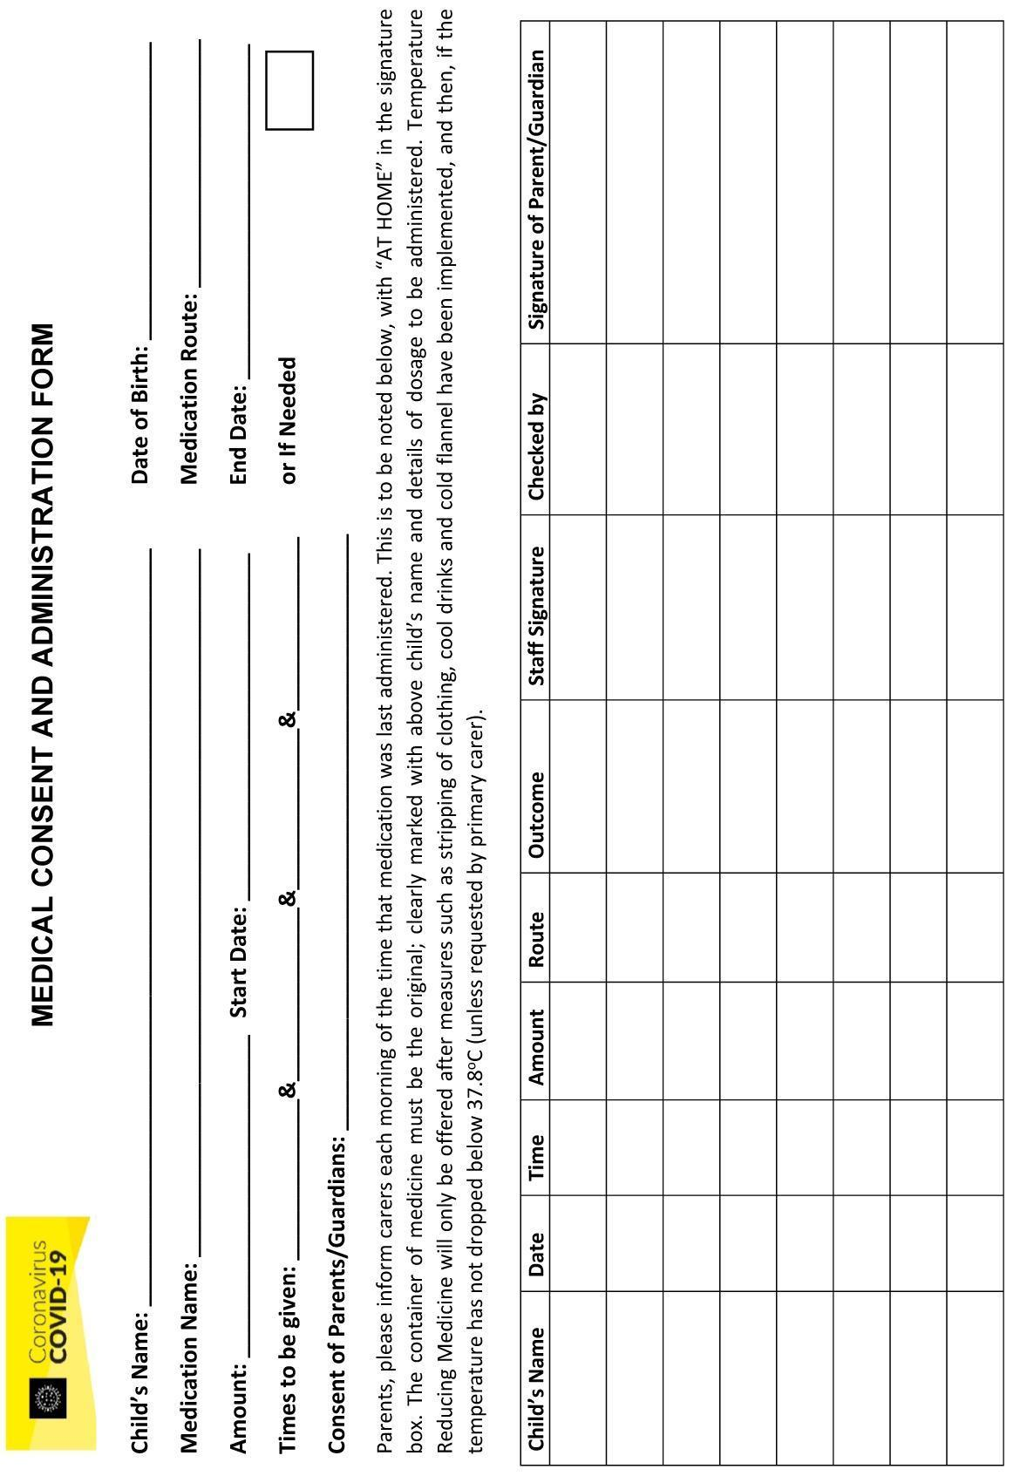
TEMPERATURE TAKING
CONSENT FORM

Name of Child: ____________________________________________

DOB of Child: ____________________________________________

Child’s Pod: ____________________________________________

I, _________________________________, consent that staff of _________________________________, can take my child’s temperature as part of the COVID-19 Risk Management Strategy.

Signed by Parents/Guardians: _________________________

Signed by Manager: _________________________

Signed by COVID Lead Representative: _________________________

Date: _________________________

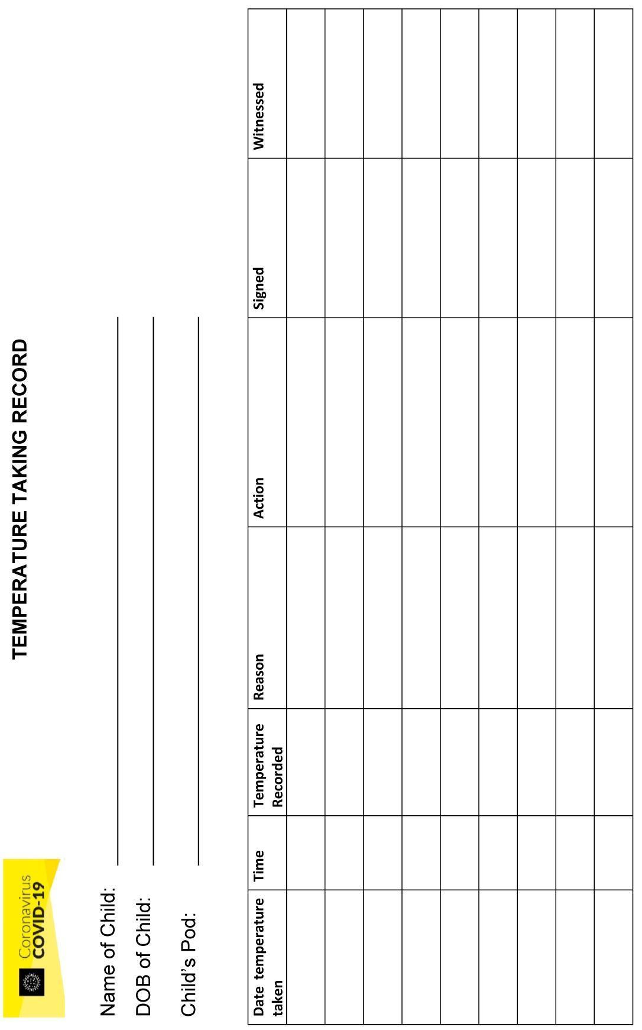

SETTLING CHILDREN IN: ADVISORY NOTE
Supporting Children to Settle Back into their Early Years Setting
When services reopen it is very important that they retain their child-centred practice, putting the needs of children to the forefront while adhering to public health advice to reduce the transmission of the virus. Children will need emotional support, nurturing and care as they transition back to childcare.
Children have been away from their childcare setting for 3 months and they will have probably missed their friends, the staff and the routine in the service. Children will have been impacted by COVID-19 and the restrictions placed on their lives. Some children may have experienced bereavement of a close family member or someone in their family may have been ill or hospitalised. While many children will have enjoyed the time with their family, others may have experienced more difficult situations such as abuse, neglect or have been impacted by domestic violence.
On their return to childcare it is very important that providers understand any impacts of COVID-19 on the children or if other significant life events have occurred for the children while away from the service. This will help the children to make a successful and happy transition back to childcare.
Some children may experience some regression in their development or their behaviour during the transition which is perfectly normal and with nurturing and care will probably settle over time.
For some children they may experience some separation anxiety from their parents on their return and become distressed about being apart from them. When young children are distressed, they can be overwhelmed and this often shows in their behaviour, which is again a normal response to stress.
Before children return to childcare
Services can support the transition back to childcare by explaining all the revised and new procedures to parents and, in this way, parents can explain the procedures to their children in a child friendly and developmentally appropriate way
Parents are really important in supporting their children’s return e.g. talking to their children about their return to the service, explaining any changes in the service, about their friends in their play pod, who will be their keyworker and answering any questions they may have.
Parents could be advised to use books, play activities and other helpful resources to talk to their children about childcare. Providing parents with some pictures of the environment and how it will be set up when they return would be very useful.
Advise parents to establish the routine that will work for them when their child returns e.g. bedtime and morning routines.
When children return to childcare
Services can support the transition back to childcare by the child’s keyworker meeting them on arrival, welcoming them back and maybe having a welcome back ‘Happy’ sticker or similar symbol to focus the children’s attention positively on their return.
Services could take a picture of the children in their play pod with their friends (with parent’s consent) which could be sent to parents and children could use it at home to talk about their friends and experiences in childcare.
Services could provide pictures of the child participating in activities to parents which again can be used as a way of talking about childcare, the children’s experiences and addressing any worries or concerns that child may have.
Where there are particular concerns about separation anxiety, parents could be advised to provide the service with a small transitional item for the child in advance of the child’s return to the service which can be easily washed and which is retained in the setting.
Where children are distressed and find it difficult to separate from their parents, suggest to the child that they just come in and see their friends and their room and, with the support of their keyworker, see if they will settle. Ask the parent to remain close to the service in case the child doesn’t settle and needs their parent.
Where a child remains distressed, having tried some of the above actions, ask the parent and child to visit the centre and see the room that they would be in at a time when the service is not operational.
Where the child remains distressed having tried some of the above actions, then arrange for the parent and child to come into the child’s room and ensure that the parent maintains 2 meters social distance from the staff and other children. Support the parent in the usual way to settle his/her child.

C:\Users\grain\Documents\Canavan Byrne\Covid 19\DCYA-ECI-TUSLA GUIDANCE\Barnardos your child's emotional well being.pdf

